PRODUCT REVIEW
We’d love to know what you think! Please share your comments with us.

Product being reviewed: 0603B07000 BOSCH PBD 40 BENCH DRILL PRESS
How would you rate this product?
X

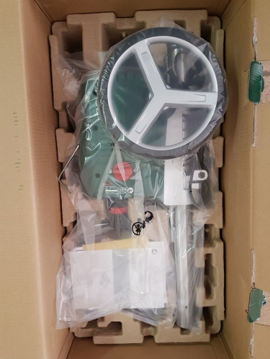
Product Review:
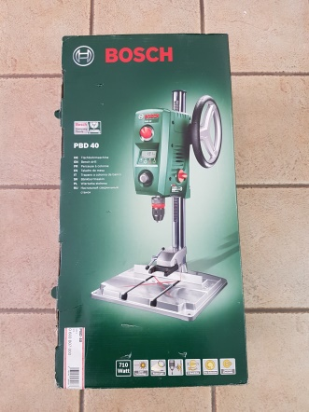
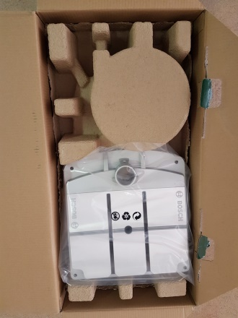
Unboxing:

The Bosch PBD 40 is neatly and securely packaged. Every component is wrapped in plastic separately which ensures nothing is damaged or scratched in transit.

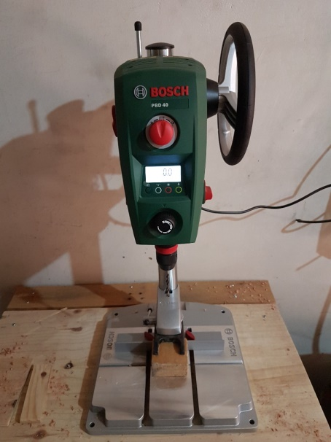
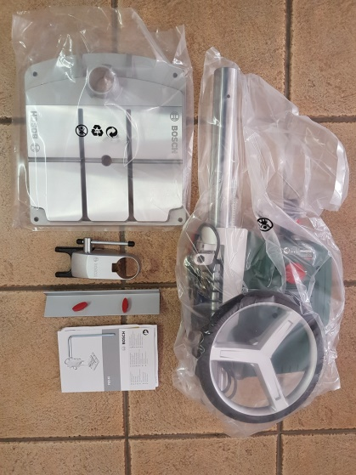
Assembly/Parts:

The PBD 40 consists of the motor housing mounted on the drilling column, base plate, hold down clamp and fence. Simply insert the hold down clamp onto the drilling column and mount the drilling column into the base plate and tighten with the provided Allen key, attach the fence and you are good to go!
Build Quality:
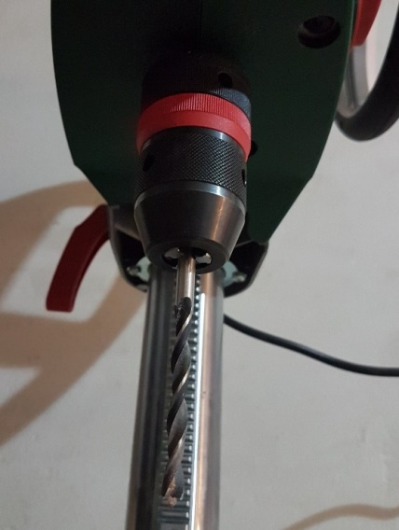
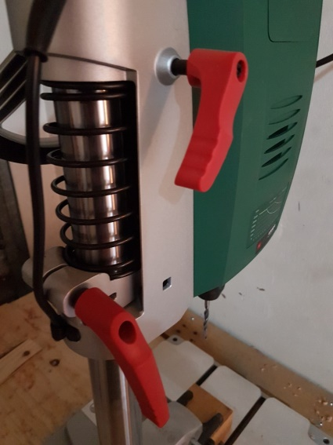
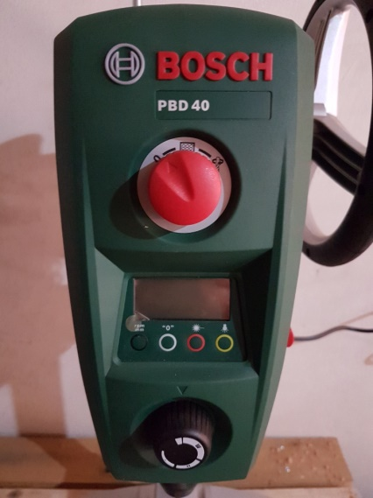

The drill press is very light weight and small, which makes it perfect for small wood working shops and minor hobbyist. It measures only 650 mm tall, and the base is 330 x 348 and weighs about 11.2 Kg. This small form factor and low weight makes it a bit wobbly and unstable when you're working with it unless you've secured it to a table. It's highly recommended to clamp or screw it to the table using the pre drilled holes in the sleek aluminium base.

The motor housing, dials, buttons and levers are all plastic. When using this lever some care must be taken not to bend it too hard as it may wear out the plastic gripping the bolt to lock the housing to the column.

Features:
This machine is packed with great features which include the already mentioned hold down clamp and fence. It also features an electronic digital display and 2-speed gearbox: high power in 1st gear, high speed in 2nd gear. This allows you to set this machine to the exact drilling speed according to your drilling application.

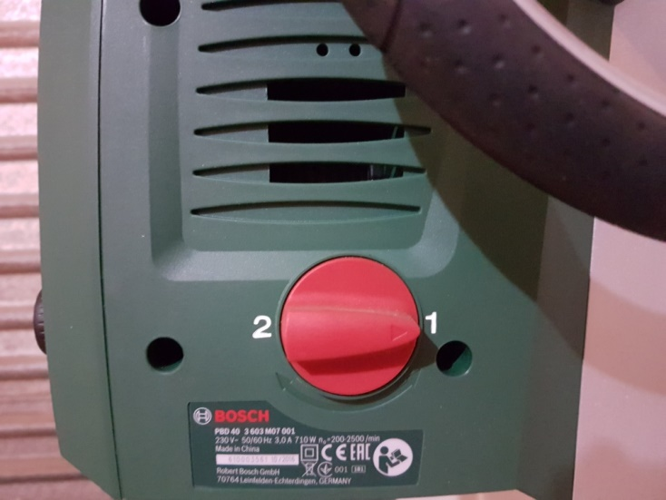
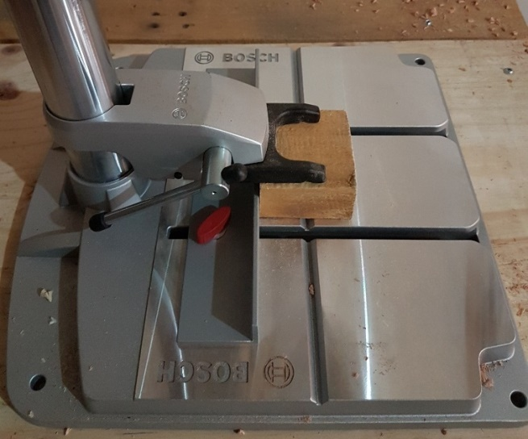

This machine is fitted with a work light and laser light for dead on accuracy. The precision keyless chuck makes changing drill bits a breeze. Chuck wobble is practically non-existent and contributes to pin point accuracy. Another great feature is the drill depth stop for precise drilling depth.

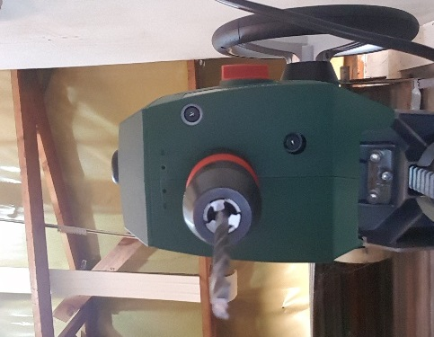
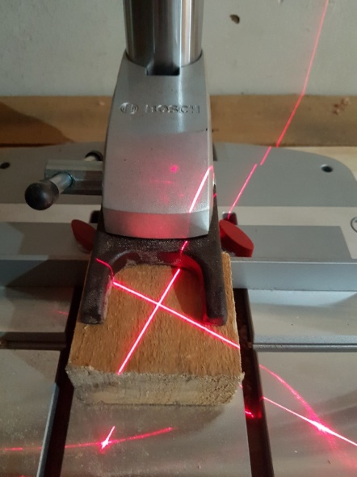
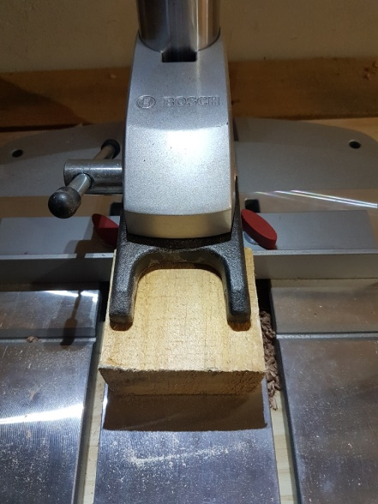

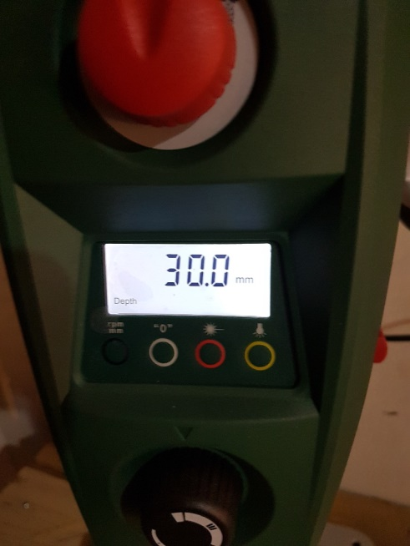

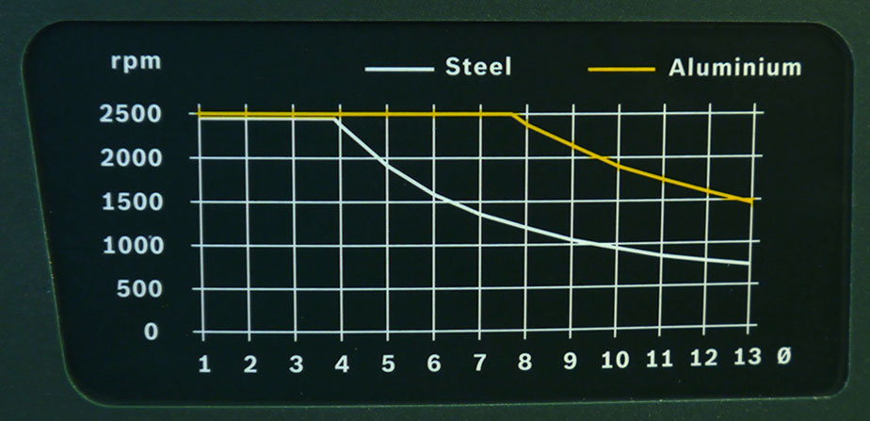

Pro’s & Con’s:
Pro’s | Con’s
Fitted with laser light for accuracy | Laser light functionality is limited when using larger diameter drill bits like Forstner bits and hole saws as this blocks the laser line from being displayed on the work piece
Light and small, easy to assemble | Lots of plastic parts and knobs
Hold down clamp and fitted fence for keeping material in place. | Wobbly and unstable when you're working with it unless you've secured it to a table
Depth stop for precise drilling depth
Select exact drilling speed according to your drilling application

Overview:
This drill press is very light and small, which makes it perfect for small woodworking shops and hobbyists jobs. The pro’s clearly outweighs the cons and I would recommend this machine without a doubt, a great investment and value for money.

